In making this Line Following Robot we need the specific materials we need in order for the robot to work

Step 1: What we need is IR Censor

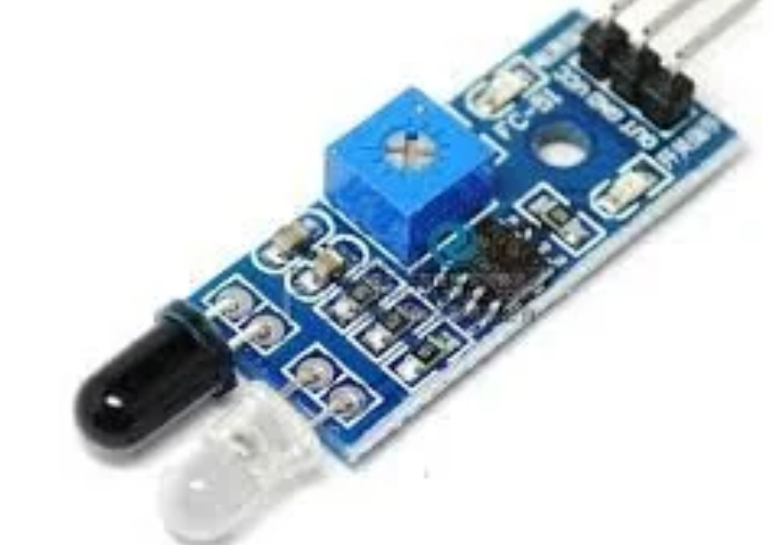

An infrared sensor is an electronic device, that emits in order to sense some aspects of the surroundings.

it gives digital output 1 and 0

when the object is in IR sensor range then it gives "1" else "0"

also when white body is present then it gives "0" and black body gives "1"

Step 2: The Program and Motor Driver to be inputted in order for the robot to follow the lines.

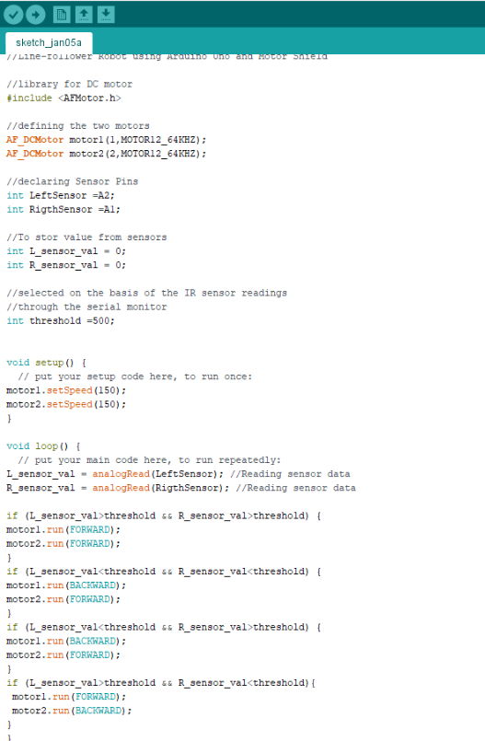

Now that we have the program and the motor driver it should be looking like this.

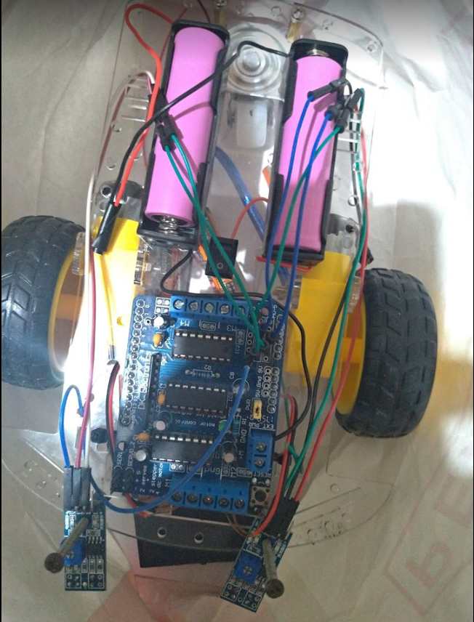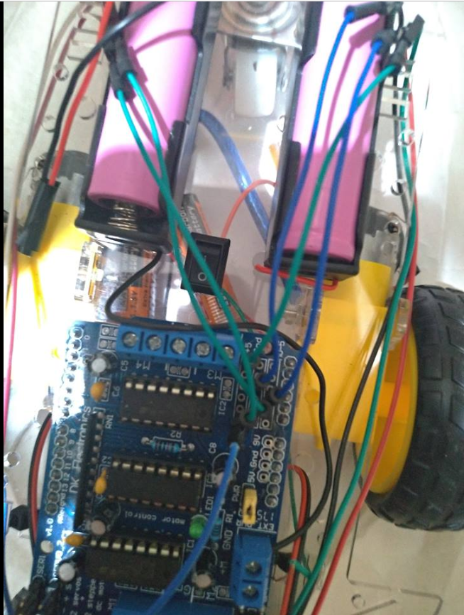

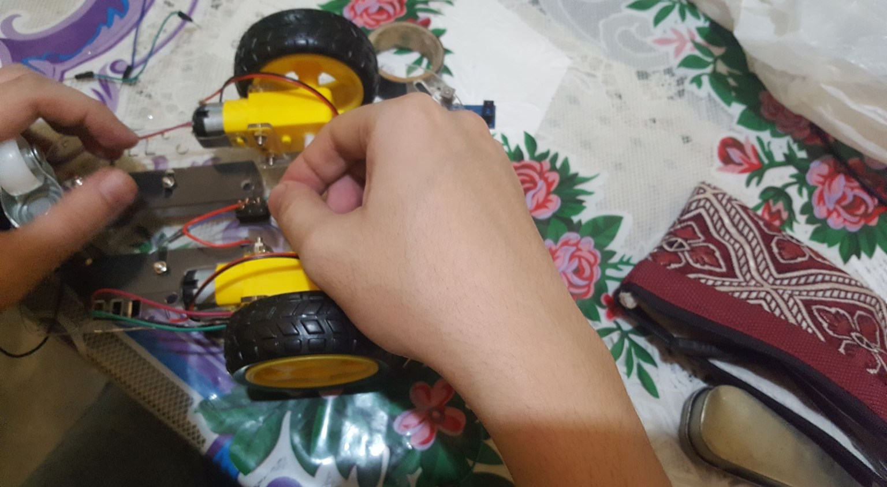Step 3: We should connect the IR to the Car Frame.

As you can see we are connecting the IR to the car frame in order for the IR to work connectively as we turn it on.

And last but not the least, The Batteries. Batteries are the most important material because without this material our robot will not work.

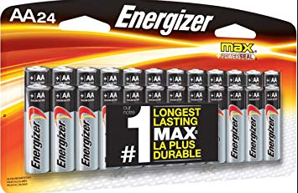

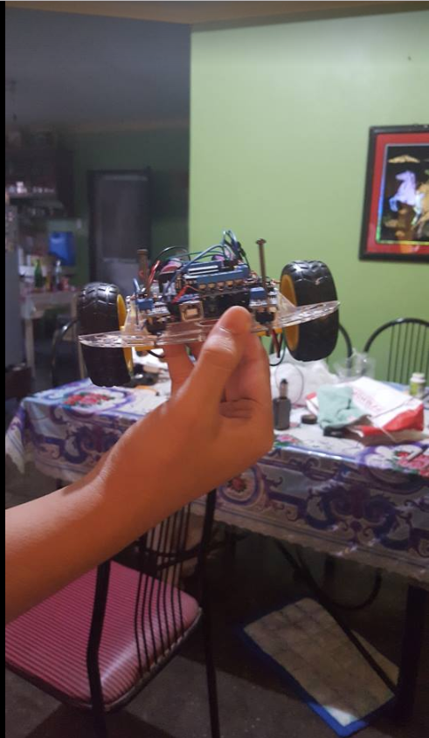Now that we have all gathered the materials we needed and finally we have attached and connect and programmed it correctly and now this is what it’s look when it is 100% done.

